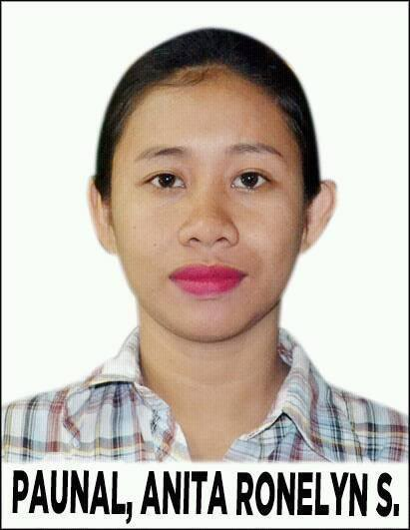**ANITA RONELYN S. PAUNAL**

Mobile #: 09351292466

E-mail:Anitaronelynpaunal@yahoo.com

Upper Banay banay, Bayawan City, Negros Oriental

**­­­­­­­­­­­­­­­­OBJECTIVE:**

Hardworking bachelor degree holder seeks opportunity to use education to excel in building the success of the company.

**PERSONAL INFORMATION:**

Name : Anita Ronelyn S. Paunal

Age : 24

Sex : Female

Status : Single

Religion : Roman Catholic

Nationality : Filipino

Language : Visayan, Tagalog, English

**Educational Background**

Tertiary : Negros Oriental State University-Sta. Catalina Campus (NORSU-BSC)

Bachelor of Elementary Education major in General Curriculum (BEED)

Date Graduated: 2016

Secondary :Tabuan National High School

Tabuan, Bayawan City,Negros Oriental

Date Graduated: 2012

Elementary :Tabuan ElementarySchool

Brgy.Tabuan Bayawan City Negros Oriental

Date Graduated: 2009

**Experience**

Patty’s Bayawan May 25, 2019-Aug. 25, 2019

Checker, Front liner

Saint Augustine academy

Part time tutorial March 6, 2018-April 15, 2018

**Skills**

* Know how to speak Filipino and English
* Computer literate
* Fast learner
* Can work under pressure
* Able to make conversation politely
* Loyal

**Character Reference**

**Anita Cataylo**

Brgy. Councilor

Banay banay, Bayawan City

Analie Laguna

Supervisor Patty’s Bayawan

09127214711

I hereby certified that the above statement is true and correct to the best of my knowledge and belief.

**ANITA RONELYN S. PAUNAL**

Applicant